

Design & Innovation Project (DIP)

Project Report

Smart Monitoring Electronic System for Environmental Noise and Dust

Project Group: E031

School of Electrical and Electronic Engineering

Academic Year 2024/25

Semester 1

Table of Contents

1. Purpose / Project Objectives
2. Project Summary
3. Scope
4. Schedule
5. Cost / Benefit
6. Outcome / Expected Outcomes
7. Project Management Review
8. Reflection
9. References

Appendix

Acknowledgement

We would like to express our gratitude to our main supervisor, Associate Professor Chan Pak Kwong, project lab technician, Mr Tay, for their support and assistance throughout the period of this Design and Innovation Project (DIP).

Table of Contents

Chapter 1 Project Purpose 4

Chapter 2 Project Summary 6

Chapter 3 Project Scope 8

3.1 Project Deliverables 8

3.1.1 Conditions 8

Chapter 4 Here you go 9

Chapter 5 System Design 9

5.1 Hardware 9

5.1.1 LoLin NodeMCU ESP8266 9

5.1.2 SEN0232 11

5.1.3 GY-BME280 13

5.1.4 PMS7003 16

5.1.5 Li-Po Battery 18

5.1.6 DC-DC Step Up Booster Converter 2.5V - 5V (5W) 19

5.1.7 2x Solar Panels – 6V, 1A 20

5.1.8 Solar Charge Controller Module 6V 2A 21

5.1.9 Custom PCB 22

Chapter 6 Schedule 26

Chapter 7 Cost 26

Chapter 8 Outcomes / Benefits 27

Chapter 9 Project Management Review 28

Chapter 10 Reflection 29

Chapter 11 Acknowledging/Declaring the Use of GAI 30

Chapter 12 References 32

# Project Purpose

According to the World Health Organisation (WHO), noise and air pollution are significant environmental factors that can have detrimental impacts on our health. Air pollution is a complex mixture of particulate matter that can come from many sources such as cars, industrial plants and many more. When inhaled, the coarser PM10 has the ability to damage our lungs whereas the finer PM2.5 can enter our bloodstream and cause a multitude of chronic illnesses. A study conducted in Volos, Greece found a positive correlation between PM2.5 levels and the number of patients admitted to emergency departments (ED) for certain respiratory issues as shown in figure X. These respiratory issues include Upper Respiratory Infection (URI), Pneumonia and Chronic Obstructive Pulmonary Disease (COPD) exacerbation.

# Project Summary

This chapter describes the problem that was solved by the project. Did the project achieve its goals: was the problem solved completely, or were there some issues that will remain unsolved?

The main function of this smart environmental monitoring system is to remotely monitor the dust and noise levels of the environment in real time, using machine learning to analyse, predict and alert the user to potentially hazardous environment conditions.

The core of this system consists of a microcontroller, sensors for detecting particulate matter (PM), decibel (dB) levels, temperature and humidity and Internet of Things (IoT) platform for data storage, visualization and predictive analysis through MATLAB. Additionally, a commonly used messaging service is used to send alerts and information to users through their mobile devices. For the system to function remotely, a lithium-ion polymer (LiPo) battery and solar panels are integrated, acting as a power source and harvesting element to allow the system to operate without an external power supply. A custom designed Printed Circuit Board (PCB) is used to connect all the components of the system together allowing the system to be more reliable, durable and compact.

Even though the system was able to achieve the majority of the project’s objectives by effectively monitoring the environmental conditions and alerting the user appropriately, the system is unable to sustain for long period of operation. This was mainly due to the lack of experience with working on new components and system design. There was also no secured enclosure created for this system, which would be ideal for making the system protected and convenient for deploying in any environment.

battery cannot last for long hours even in ideal sunny conditions. This is mainly due to the poor selection of the solar panels used. The output power is more than the input power from the solar panels causing the battery to eventually deplete. This can also cause some sensors to not work properly after a while as some sensors require a consistent Voltage Input.When the battery depletes over time, the voltage output of the battery will decrease below the required voltage of the sensos.

Another area where improvements could be made is to create a secure enclosure for the system using 3D printing. The reason for not making a secured enclosure is due to time taken to troubleshoot... TO CONTINUE

# Project Scope

This section summarizes the final total scope of the project.

* Project Deliverables. This section gives an overall description of all the project outputs.
* Summary of the work/activities that were performed to produce those outputs.
* Changes. Were there any changes to the original scope? Highlight the changes / change requests,

## Project Deliverables

There are some conditions that justify this project to be successful. This is the main fundamentals that would meet the project's objective and completion of this DIP module

### Conditions

1. Integration of ESP8266 with Sensors and IoT platforms

Our microcontroller, ESP8266, is the glue to the system. Due to the IoT capabilities, the ESP8266 can allow IoT platforms to read and analyse data gathered from the hardware sensors that are directly connected to the ESP8266.

1. IoT

# Here you go

# Overall System Design

## Hardware

The hardware side of the project consists of the microcontroller - ESP8266, Sensors - SEN0232, BME280, PMS7003 and Power Supply System – DC step up, Solar Charger controller, Solar Panels, LiPo Battery. All hardware modules used are connected to a custom PCB. A more detailed Specification of each module can be found in Appendix (X).

### LoLin NodeMCU ESP8266

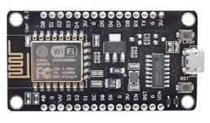[1]

#### Function

This microcontroller is widely used for various IoT applications due to its surface-mountable WiFi module with an embedded ESP8266 system on chip (SoC). It is capable for onboard data processing and integration with sensors through general-purpose input/output (GPIO) pins and power supply pins. ESP8266 is programmable with the Arduino integrated development environment (IDE) that has a wide range of libraries that provides extra functionality to the microcontroller. [2]

#### Specification

|  |  |
| --- | --- |
| Core | 1 |
| Architecture | 32 bits |
| Clock Speed | 80Mhz |
| WiFi | IEEE802.11 b/g/n support for WPA and WPA2 |
| RAM | 160KB - 64KB Instruction - 96KB Data |
| Flash | 4MB |
| Digital I/O Pins | 11 |
| Analog I/O Pins | 1 |
| Interfaces | Inter-Intergrated Circuit (I2C) - Serial Peripheral Interface (SPI) - Universal asynchronous receiver / transmitter (UART) - Inter-Integrated Circuit Sound (I2S) |
| Operating Voltage | 3.3V |
| Module Size | 58mm*32mm |

[1] //to add caption (offline mode only)

#### Justification

The ESP8266 is a low cost and low powered module that has built-in features that are suitable for this project like WiFi and GPIO pins. With this module being able to be programmed by Arduino IDE, it has community and documentation support resulting in a large compatibility with sensors and libraries. Therefore, this microcontroller can allow us to meet the objectives of the project.

### SEN0232

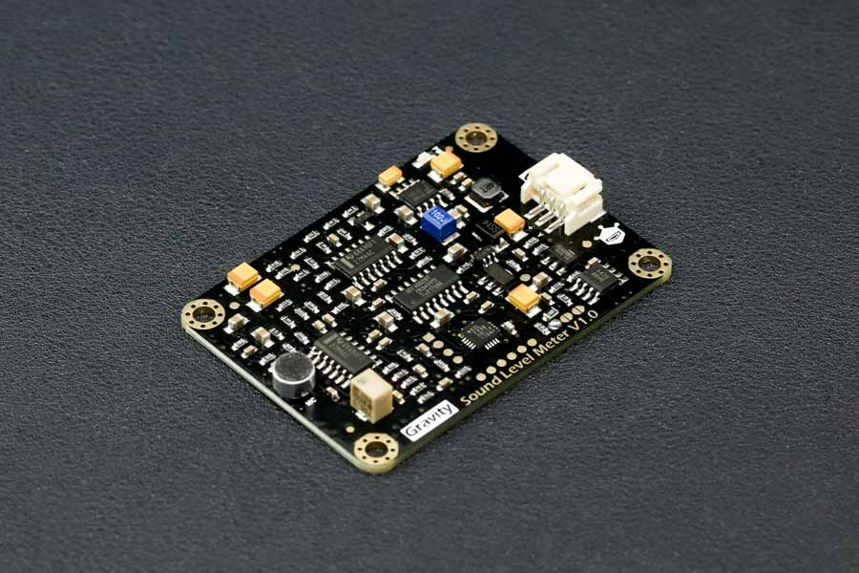[3]

#### Function

The SEN0232 is an Analog Sound Level Meter that is designed to accurately measure the sound level of the surrounding environment. This is achieved by using an instrument circuit and a low noise microphone. With a provided connector, this is a plug-and-play component which is user friendly and compatible with a lot of IoT devices due to its wide input voltage of 3.3-5V and outputs a maximum of 2.6V which linearly follows the decibel value of the surrounding environment. [3]

#### Specifications

|  |  |
| --- | --- |
| Input Voltage | 3.3V - 5V |
| Current consumption | 22mA @ 3.3V, 14mA @ 5V |
| Output Voltage | 0.6V - 2.6V |
| Measuring Range | 30dBA - 130dBA |
| Measurement Error | ±1.5dB |
| Module Size | 60mm * 43mm |

[3]

#### Justification

Due to its ease of use, wide input voltage of 3.3V-5V and low input current of 22mA at 3.3V, the SEN0232 is an ideal Sound Level Meter to integrate with the ESP8266. It also has a wide measuring range of 30dBA ~ 130dBA with a measurement error of ±1.5dB. The module size is also easy to integrate with its size of 60mm*40mm.

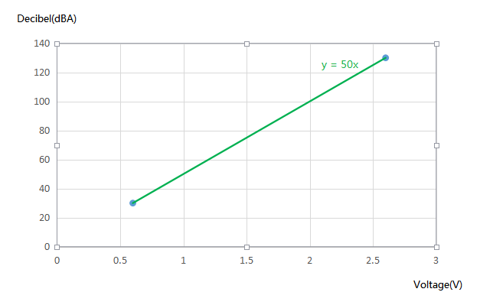[3]

Additionally, from the figure above, the correlation between the decibel level and voltage output is linear, this simplifies the code without the need for complex algorithms. Suitable for new and experienced students taking on this project.

### GY-BME280

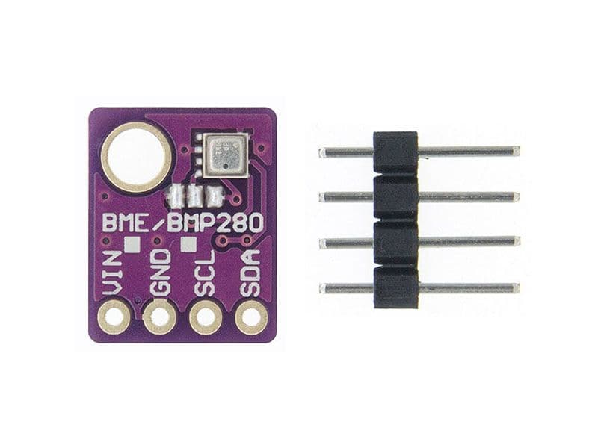[4]

#### Function

This module is an environmental sensor that measures the surrounding pressure, humidity and temperature. Thanks to its low power consumption, it can be easily implemented in battery driven systems. This sensor uses an I2C communication protocol to exchange data with a microcontroller. [5]

#### Specification

|  |  |
| --- | --- |
| Input Voltage | 3.3V - 5V |
| Current consumption | 0.4mA |
| Temperature Range | -40°C to 85°C |
| Temperature Accuracy | ±1°C |
| Humidity Accuracy | ±3% |
| Pressure Range | 300 hPa – 1100 hPa |
| Pressure Accuracy | ±1.0 hPa |
| Module Size | 14mm*11mm |
| Communication Protocol | I2C |

[4]

#### Justification

This sensor can operate on a 3.3V source and communicate using I2C communication protocol that the ESP8266 is capable of. This would make the connection very simple. However, to receive readings, an Adafruit_BME280 library needs to be installed and utilized.[5] This is an easy process to complete, and the library allows the code to be readable. The module size is also easy to integrate to any system with its size of 14mm*11mm.

### PMS7003

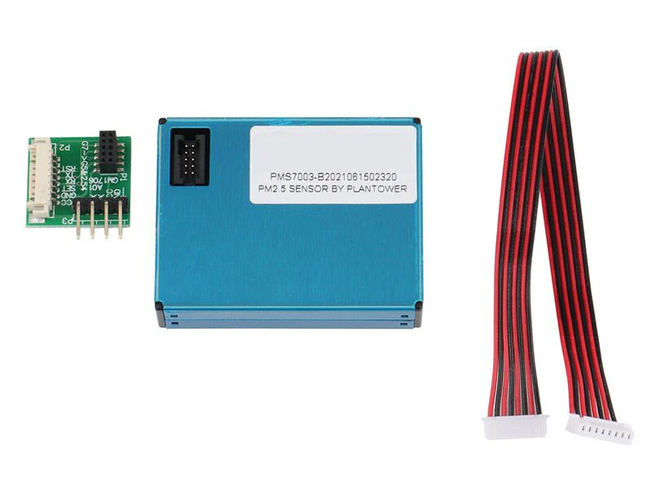[6]

#### Function

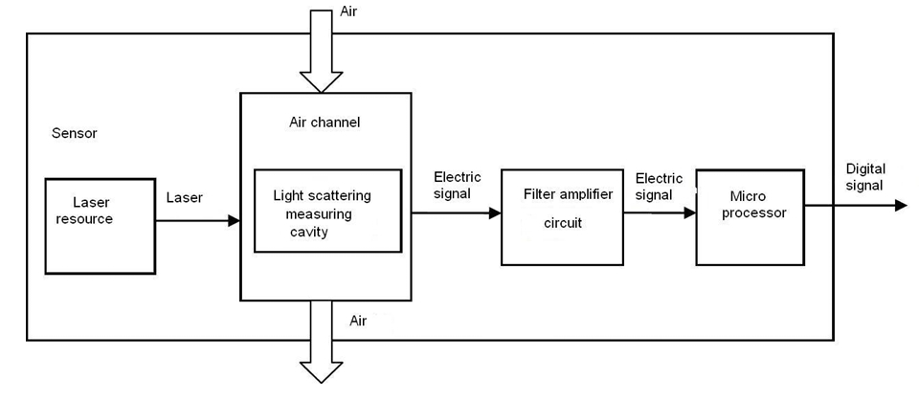[7]

PMS7003 is a particle concentration sensor that obtains the number of suspended particles in the surrounding air and outputs the result digitally via I2C communication protocol. This is possible by the Laser scattering principle by using laser to radiate suspending participles which then produces scattering. With this, the microprocessor of the module can determine the particle diameter and number of particles based on the MIE theory calculation [7]

#### Specification

|  |  |
| --- | --- |
| Input Voltage | 4.5V - 5.5V |
| Current consumption (Active Mode) | ≤100mA |
| Range of measurement | 0.3μm - 1.0μm ；1.0μm - 2.5μm ；2.5μm - 10μm |
| Effective Range (PM2.5 standard) | 0μg/m³ - 500μg/m³ |
| Maximum Consistency Error (PM2.5 standard) | ±10%@100~500μ g/m³  ±10μ g/m³@0~100μ g/m³ |
| Module Size | 48mm*37mm*12mm |

[7]

#### Justification

This module is sensitive, accurate and reliable and has counting efficiency of 98% for particles larger than 0.5μm. Additional features of zero false alarms and high anti-interference capabilities allow this module to provide consistent data accuracy which makes this module suitable for varying environments. This module also has simple serial digital output that allows easy connection to the ESP8266. Lastly, its slim design allows easy integration into various devices.

### Li-Po Battery

hello
[8]

#### Function

This battery is a compact and rechargeable source that is designed for portable applications that require a power source without the need for external power source. It provides an output voltage of 3.7V that makes it suitable for IoT applications. Its slim profile enables the battery to be lightweight and integrated into compact designs where space and weight are constrained. The battery includes a protective circuit to prevent overcharging which would allow the battery to have a longer life span.

#### Specifications

|  |  |
| --- | --- |
| Output Voltage | 3.7V |
| Working Current (Max) | 1500mAh |
| Battery Type | Lithium Polymer (Li-Po) |
| Connector | PH2.0 |
| Battery Size | 50mm*35mm*10mm |

[9]

#### Justification

To make this system portable, we needed an internal power source that is slim, lightweight and provides enough power to supply the ESP8266. With the ESP8266 and most of the modules used in this system only requiring 3.3V, this battery will be able to supply the required power. For the PMS7003 that requires 5V, a DC-DC step up module is used to output 5V to supply. Solar Panels will be integrated to the system to harvest power to charge the battery.

### DC-DC Step Up Booster Converter 2.5V - 5V (5W)

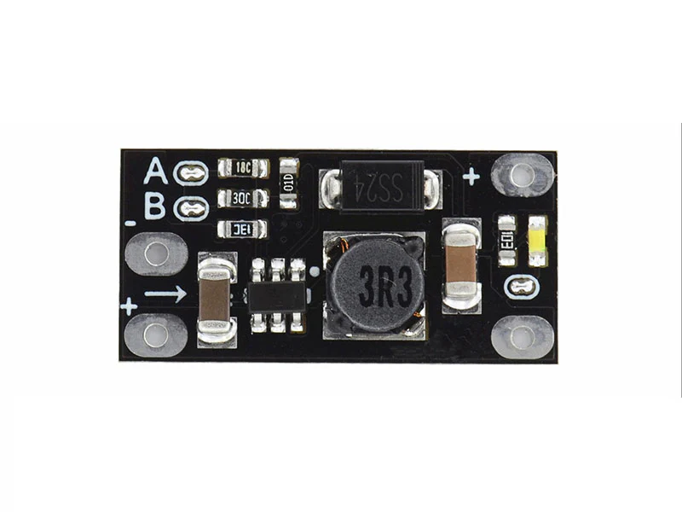[10]

#### Function

This is a module that ultilises a step-up topology to convert the low input voltage, starting from 2.5V, to a wide range of output voltage from 5V – 12V with a maximum power output of 5W. Selecting the output voltage can be done by cutting the A & B traces accordingly. Therefore, this module is useful for other modules that require an output voltage higher than the available source. [10]

#### Specification

|  |  |
| --- | --- |
| Input Voltage | 2.5V - Vout |
| Output Voltage | 5V / 8V / 9V / 12V |
| Output Current | 3.7V Input: 5V 1A / 8V 0.5A / 9V 0.45A / 12V 0.3A  5V Input: 8V 0.7A / 9V 0.7A / 12V 0.5A |
| Module Size | 22mm*11mm*3.6mm |

[10]

#### Justification

The main purpose for choosing this module is to provide the correct input voltage to the PMS7003

sensor that requires 5V as the Li-Po battery used in the system is only able to output 3.7V. When this module outputs 5V, it can provide an output current of 1A which is sufficient for the PMS7003 module to operate.

### 2x Solar Panels – 6V, 1A

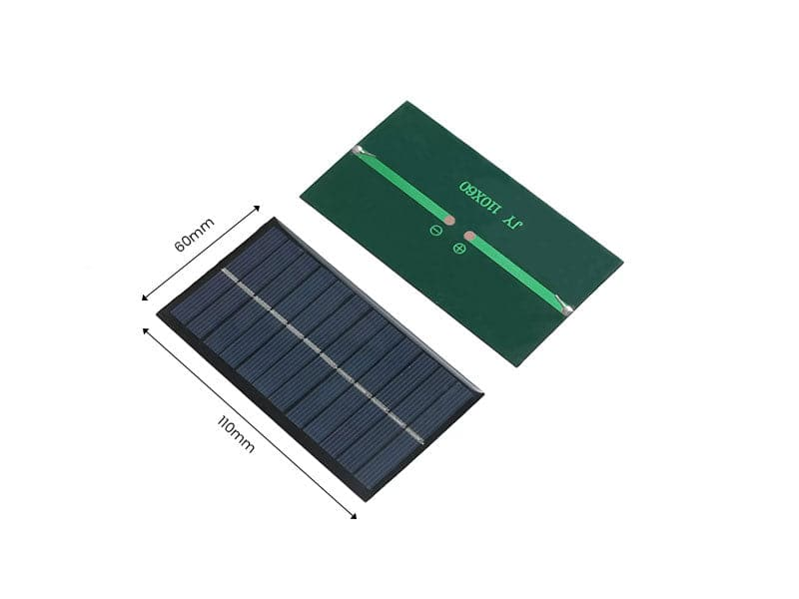[11]

#### Function

The solar panel is designed to be a renewable power source that converts sunlight to electrical energy. This solar panel is compact and efficient and can output a maximum power of 1W which makes it suitable for low-powered devices that would be exposed to the sun. When connected to a charge controller, it can be used to charge rechargeable batteries like Li-Po batteries.

#### Specification

|  |  |
| --- | --- |
| Output Voltage (Max) | 6V |
| Power | 1W |
| Module Size | 110m*60mm*2.5mm |

[11]

#### Justification

To make the system portable and operate in an outdoor environment, a solar panel is needed to charge the internal Li-Po battery. The solar panel is also lightweight and has a durable design which can be easily integrated into most systems. Two solar panels are used to make charging the battery faster which would make the system operate longer.

### Solar Charge Controller Module 6V 2A

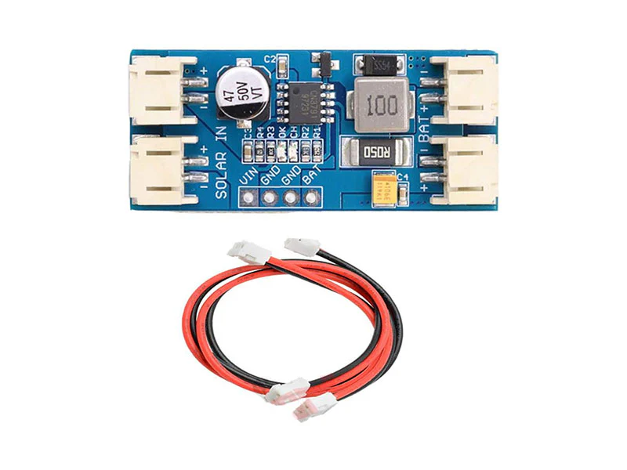[12]

#### Function

The main function of this module is to regulate the voltage output of a 6V solar panel and manage the charging process of the Li-Po battery with Pulse Width Modulation (PWM). This would ensure that the battery receives a gradual and controlled charge which would result in a long-life span and better performance for the battery. [12]

#### Specification

|  |  |
| --- | --- |
| Input Voltage (Max) | 6V |
| Output Voltage | Nominal 3.7V, Full Charge 4.2V |
| Charging Current (Max) | 2A |
| PWM Frequency | 300kHz |
| Module Size | 45mm*20mm*9.5mm |

[12]

#### Justification

To charge the Li-Po battery in the system, a controller module is needed. This module works nicely with the solar panel used as it can take up to 6V which is the maximum output voltage of the solar panel. Additionally, the small profile of the module makes it easy to integrate into the system.

### Custom PCB

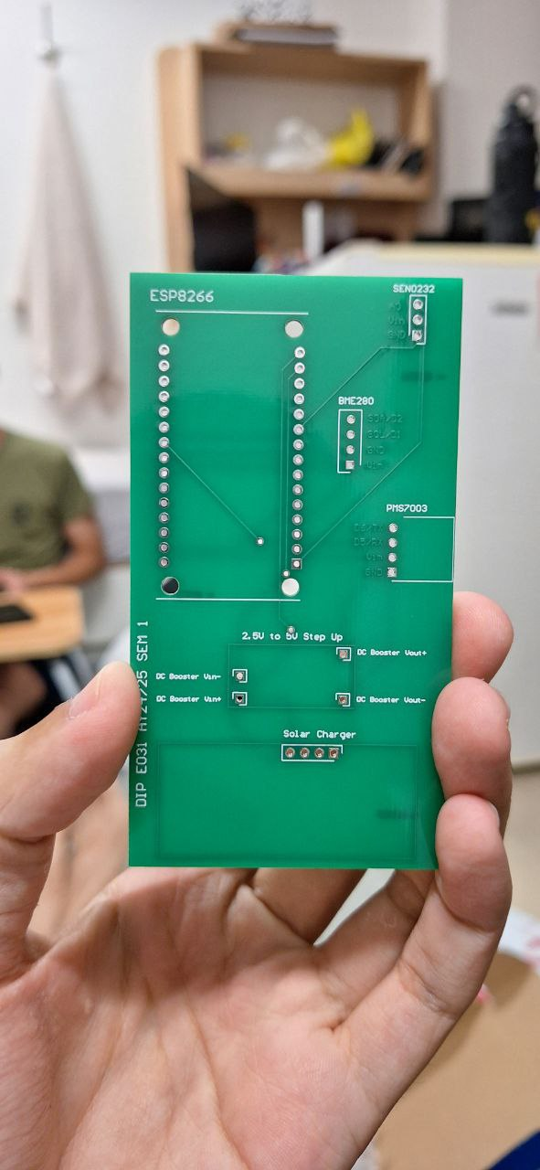

#### Function

The function of the custom PCB is to have a more compact and reliable circuit design for the system. By using PCB design software, human errors in the circuit design will be significantly reduced due to the error checking feature. Additionally, the traces in the PCB would be more reliable and are less prone to interference. Minimal soldering is required, and the general look of the circuit would be better.

#### PCB Design Software

[13]

Altium Design is a software tool used to create and manage PCB designs. It uses schematic design; PCB layout and 3D modeling to design and manage circuits. Features like auto routing, real-time error checks and extensive component libraries make this software one of the best in the industry. Allowing users to create their custom PCB faster while reducing mistakes done by users. Additionally, Altium Design supports team collaboration and version control which is a crucial feature for professionals working together on the same project.

#### Schematic Design & 3D Model

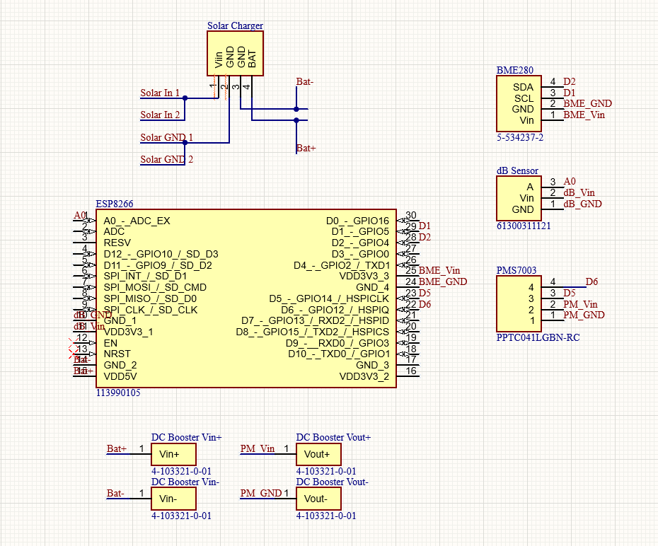

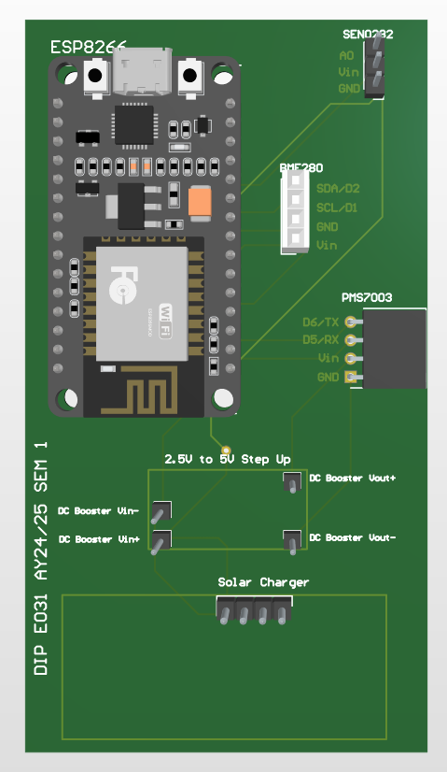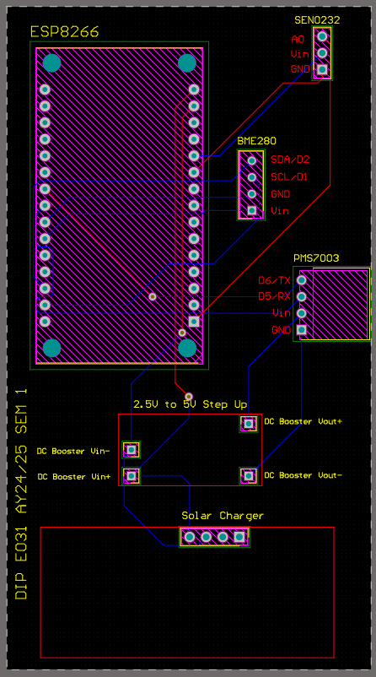[figure from altium]

#### Justification

Custom PCB design is made to help make the system more compact and to increase reliability. This is done by soldering some sensors and modules to the PCB which improves durability. The components are also arranged specifically for optimal placement of each sensor which would make the overall system size to be smaller when compared to using a temporary breadboard for connections. Therefore, the overall system will look neater and easier for broader deployment if needed as PCBs are easy to duplicate.

# Schedule

|  |  |  |
| --- | --- | --- |
| PHASE | Planned Milestone Date | Actual Milestone Date |
| Initiating Phase |  |  |
| Planning Phase |  |  |
| Execution Phase |  |  |
| Closing Phase |  |  |
| Project End Date |  |  |

<Explain differences in between the planned and actual schedules>

<Description of Benefits>

# Cost

|  |  |  |
| --- | --- | --- |
| PHASE | Planned Costs | Actual Costs |
| Planning Phase  (Week 1 – 4) | $0.00 | $0.00 |
| Execution Phase  (Week 5 – 11) | $200.00 | $165.00 |
| Closing Phase  (Week 12 – 13) | $0.00 | $0.00 |
| **Project Total Costs** | $200.00 | $165.00 |

Planned Costs

<Explain differences between the planned and actual costs>

# Outcomes / Benefits

* Outcomes
* Benefits

# Project Management Review

This section should cover the following points

* Project initiation

Review if the initial objectives are specific, measurable, achievable, relevant, and time bound.

* Project planning

Is the project properly scheduled? Are the roles and responsibilities clearly defined?

* Project manager role

Review communication and motivation strategies and their impacts on project progress and outcome. Elaborate on monitoring and control activities necessary to ensure health progress, and how changes and challenges are managed if any.

* Cost management
* Risk management

# Reflection

This section should cover the following points

* Engineering knowledge
* Problem Analysis
* Design/development of Solutions
* Individual and Team Work
* Future Recommendations.

Within the 13 weeks, there was much engineering knowledge utilized to resolve and overcome any challenges faced. the engineering knowledge and techniques used was mainly from Circuit Analysis and Analog Electronics

# Acknowledging/Declaring the Use of GAI

Please refer to NTU's Current Policy & Guidelines on the Use of Generative AI available in NTUlearn home page and the link:

<https://entuedu.sharepoint.com/sites/Student/dept/ctlp/SitePages/Exploring-the-Impact-of-Generative-Artificial-Intelligence-(GAI)-Tools-on-Education.aspx>

* Complete the following declaration if applicable.
* Create a Paper Trail to document the input prompt, output obtained, and how you have used it

I __________________________________________________________ (student name), __________________@e.ntu.edu.sg (NTU email) honestly and sincerely make the following declaration in relation to the following course submission:

1. Name of course:

2. Course Code:

3. Instructor:

4. Title of Assignment/Project Submission:

In relation to the foregoing I hereby declare that, fully and properly in accordance with the Assignment/Project Instructions I have (check where appropriate):

i. Used GAI as permitted to assist in generating key ideas only. ☐

ii. Used GAI as permitted to assist in generating a first text only. ☐

And/or

iii. Used GAI to refine syntax and grammar for correct language submission only. ☐

Or

iv. As it is not permitted: Not used GAI assistance in any way in the development or generation of this assignment or project. ☐

I also declare that I have :

a. Fully and honestly submitted the digital paper trail required under the assignment/project instructions; and that

b. Wherever GAI assistance has been employed in the submission in word or paraphrase or inclusion of a significant idea or fact suggested by the GAI assistant, I have acknowledged this by a footnote; and that,

c. Apart from the foregoing notices, the submission is wholly my own work.

_____________________________ _________________

Student Name & Signature Date

# References

[1] ‘NodeMCU ESP8266 Specifications, Overview and Setting Up’. Accessed: Nov. 11, 2024. [Online]. Available: <https://www.make-it.ca/nodemcu-details-specifications/>

[2] I. Hübschmann, ‘Is the ESP8266 WiFi Module the Right Choice for You?’, Nabto. Accessed: Nov. 11, 2024. [Online]. Available: <https://www.nabto.com/is-esp8266-wifi-module-right-choice-for-you/>

[3] ‘Gravity__Analog_Sound_Level_Meter_SKU_SEN0232-DFRobot’. Accessed: Nov. 11, 2024. [Online]. Available: <https://wiki.dfrobot.com/Gravity__Analog_Sound_Level_Meter_SKU_SEN0232>

[4] ‘Temperature Barometer Sensor BMP280 - Default Title’, Kuriosity. Accessed: Nov. 11, 2024. [Online]. Available: <https://kuriosity.sg/products/temperatureebarometer-sensor-bmp280?variant=447572991347777>

[5] ‘ESP8266 with BME280 using Arduino IDE (Pressure, Temperature, Humidity) | Random Nerd Tutorials’. Accessed: Nov. 11, 2024. [Online]. Available: <https://randomnerdtutorials.com/esp8266-bme280-arduino-ide/>

[6] ‘PM2.5 Dust Sensor PMS7003’, Kuriosity. Accessed: Nov. 11, 2024. [Online]. Available: <https://kuriosity.sg/products/pm2-5-dust-sensor-pms7003>

[7] P. Zhou, "PMS7003 Series Data Manual," Plantower, Ver. 2.5, Jun. 2016. [Online]. Available: <https://www.espruino.com/datasheets/PMS7003.pdf>

[8] ‘3.7V~High Temperature Series - Zhongshun Xinneng’, ZONCELL. Accessed: Nov. 11, 2024. [Online]. Available: <https://www.zoncell.com/en/product/lp1s-t/>

[9] ‘3.7V Li-Po Lithium Polymer Battery 100mAh 600mAh 1200mAh 1600mAh 2000m’, Kuriosity. Accessed: Nov. 11, 2024. [Online]. Available: <https://kuriosity.sg/products/3-7v-li-po-lithium-polymer-battery-100mah-600mah-1200mah-1600mah-2000mah-5000mah>

[10] ‘DC-DC Step Up Boost Converter 2.5 - VOUT to 5 - 12V (1A) 5W’, Kuriosity. Accessed: Nov. 11, 2024. [Online]. Available: <https://kuriosity.sg/products/dc-dc-step-up-boost-converter-2-5-vout-to-5-12v-1a-5w>

[11] ‘Solar Panel 6V 1W’, Kuriosity. Accessed: Nov. 11, 2024. [Online]. Available: <https://kuriosity.sg/products/solar-panel-6v-1w>

[12] ‘Solar Charge Controller Module 6V 2A - Kuriosity’. Accessed: Nov. 11, 2024. [Online]. Available: <https://kuriosity.sg/products/solar-charge-controller-module-6v-2a?_pos=1&_psq=solar+contro&_ss=e&_v=1.0>

[13] ‘Altium Designer - PCB Design Software’. Accessed: Nov. 11, 2024. [Online]. Available: <https://www.altium.com/altium-designer>

**Appendix A -** Project Members Information

|  |  |  |  |
| --- | --- | --- | --- |
|  | Name | Project contributions | Report Contribution |
| 1 | Muhammad Azfar Nasri Bin Azman | * Group Leader * Hardware Team: Hardware Research * Hardware Team: Hardware Connection, Testing and Troubleshooting * Hardware Team: ESP8266 / Arduino Programming * Hardware Team: PCB Design * Software Team (Telebot): Telegram Bot Code * Purchasing of Hardware Items | e.g. Pages 3-6, 24-25, Chapter 2, Appendix A, B, .. |
| 2 | Danial Ong | * Treasurer |  |
| 3 | Darryl Tan Han Yu | * Software Team (Data Analysis): Visualisation Gauge Tools * Software Team (Telebot): Telegram Bot Code * Software Team: Debugging |  |
| 4 | Dylan Ser Zi Ler | * Software Team (Data Analysis): Predictive Analysis for PM2.5 & PM10 * Software Team (Data Analysis): Data Visualisation Plotted Data Trends * Software Team (Data Analysis): Average Predicted Values & ThingSpeak Dashboard * Software Team (Telebot): Telegram Bot Code * Software Team: Debugging |  |
| 5 | Ignatius Chin Zheng Hao | * Software Team (Data Analysis): Predictive Analysis for Sound (dB) * Software Team (Data Analysis): Data Visualisation Gauge Tools & Plotted Data Trends * Software Team (Telebot): Telegram Bot Code |  |
| 6 | Muhammad Saajud S/O  Jiaudden |  |  |
| 7 | Geng Zhiwei |  |  |
| 8 | Bu Yizhe |  |  |
|  |  |  |  |
|  |  | e.g. project video, final packaging, business proposal, group report editor, final project integration, final presentation presenter, secured industry sponsorship, |  |

Sub-Group Members List:

Hardware Team: Azfar, Danial

Software Team (Data Analysis): Darryl, Dylan, Ignatius

Software Team (Telebot): Azfar, Darryl, Dylan, Ignatius

Appendix B – (no page limit for appendices)

[1]

M. Mir, F. Nasirzadeh, H. Bereznicki, P. Enticott, S. Lee, and A. Mills, ‘Construction noise effects on human health: Evidence from physiological measures’, *Sustainable Cities and Society*, vol. 91, p. 104470, Apr. 2023, doi: [10.1016/j.scs.2023.104470](https://doi.org/10.1016/j.scs.2023.104470).